In Jenkins 🡪 Slave windows…

Take one AWS EC2 Linux instance…

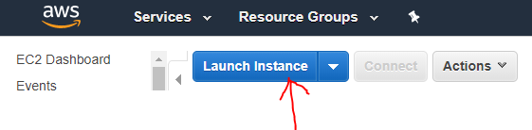

Click Select

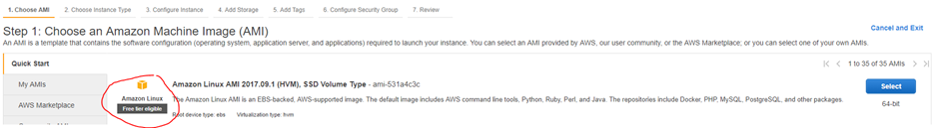

NEXT Configure instance Details



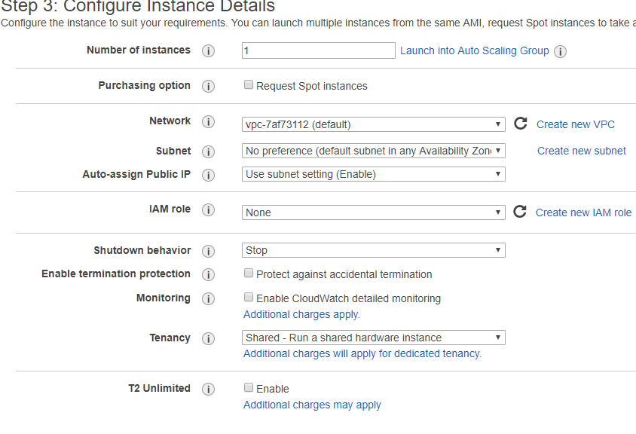

NEXT Add Storage



NEXT Add Tags



NEXT Configure Security Group

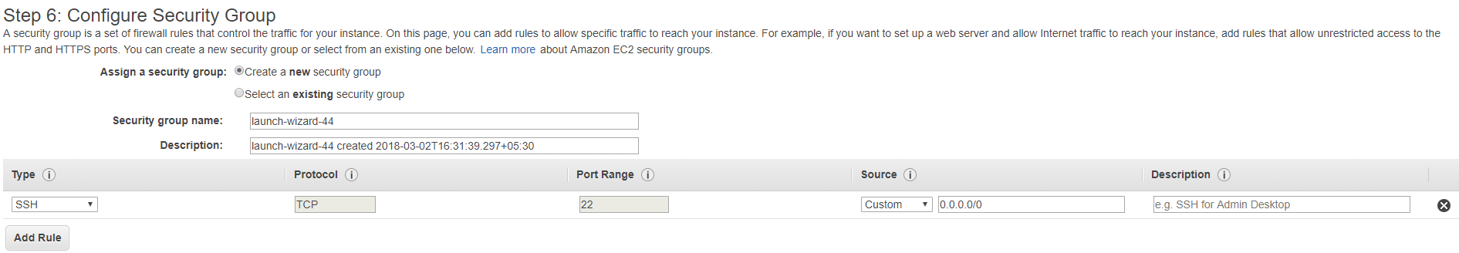

NEXT



Create New key Pair

Example : Jenkins (any Name you can give here)

Click 🡪Download Key Pair

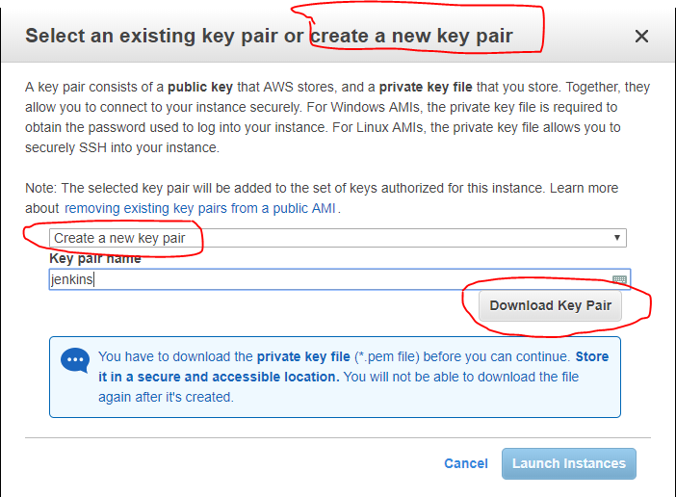

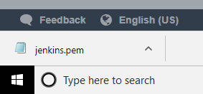

Now Launch the instance..

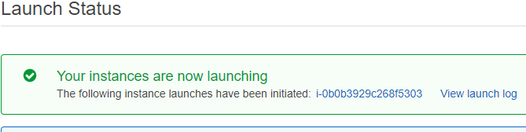

EC2 Dashboard



Now take putty key generator tool

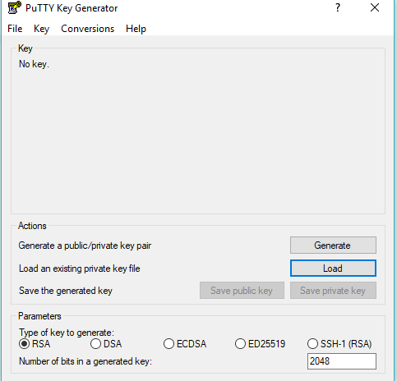

Now click Load Button

It will goes to “download Folder” there is our “New key pair” Example : Jenkins

Pick that key ….and click open button

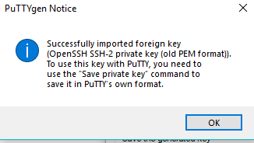

Click ok button

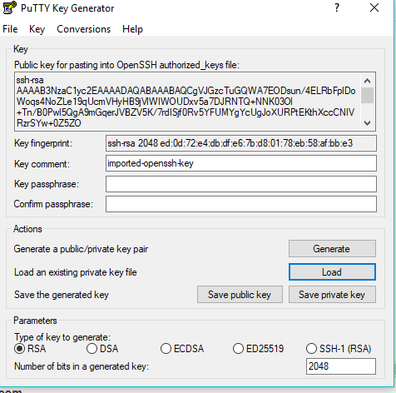

Click Save private key on Desktop..

NOW

Copy Public IP address of this instance..

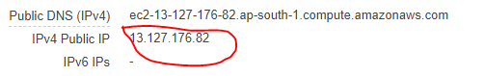

Paste in putty Configuration tool

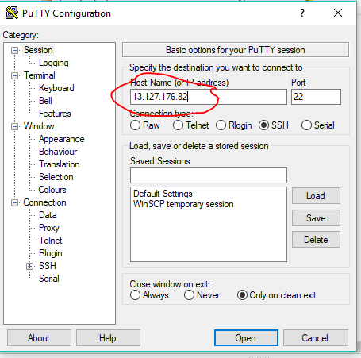

left side there is option SSH

Auth

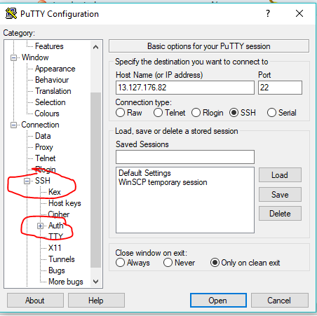

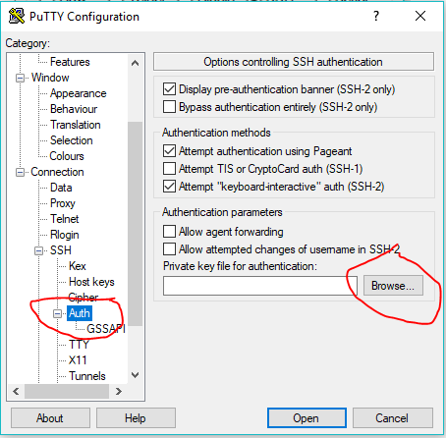

Browse …your key pair…(key on Desktop)

Now you are in linux terminal

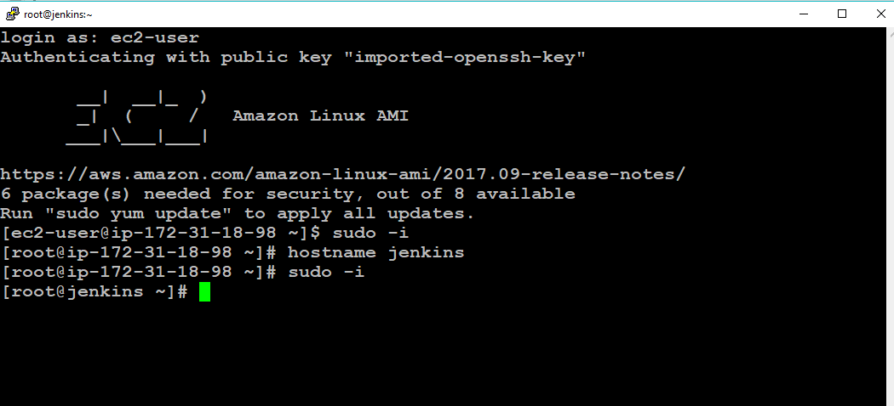

Type these commands..

Terminal refresh

#yum update –y

Install git

#Yum install git

Install java (java install in centos)

<https://tecadmin.net/install-java-8-on-centos-rhel-and-fedora/>

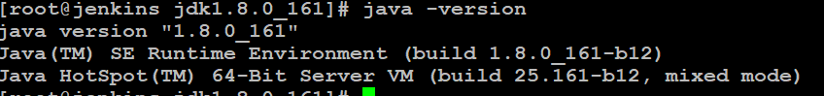

Install Apache maven

<https://tecadmin.net/install-apache-maven-on-centos/>

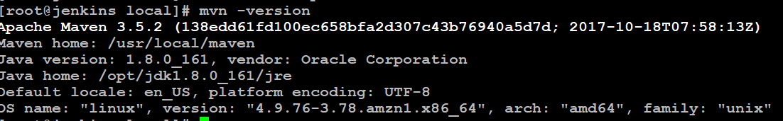

Now install Jenkins

Go to Jenkins.io

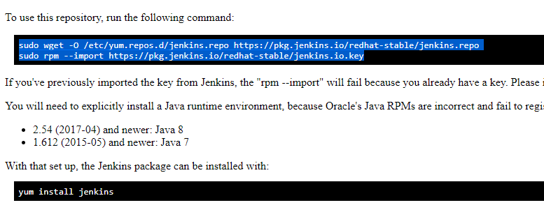

After installing

Start Jenkins

#service Jenkins start

Jenkins default port number is :8080

Now go to Jenkins EC2 instance 🡪security groups

Open port number 8080



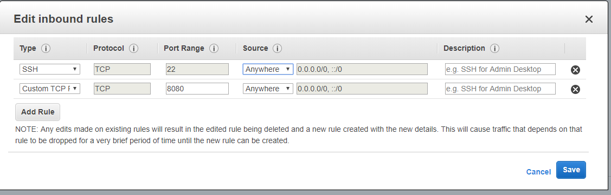

Now copy Jenkins instance public ip + 8080..

Paste it browser…open like below pic…copy that folder paste in terminal

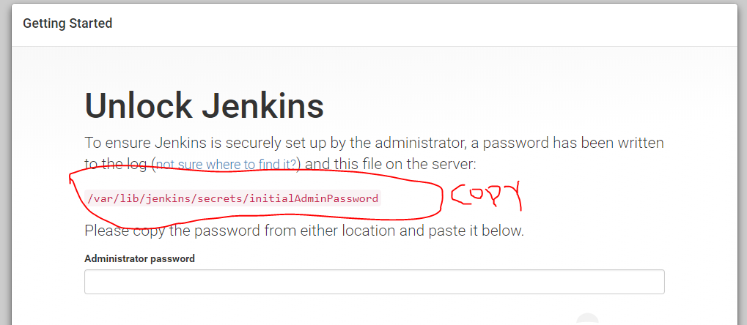



Copy the encrypted password

And paste it like below pic

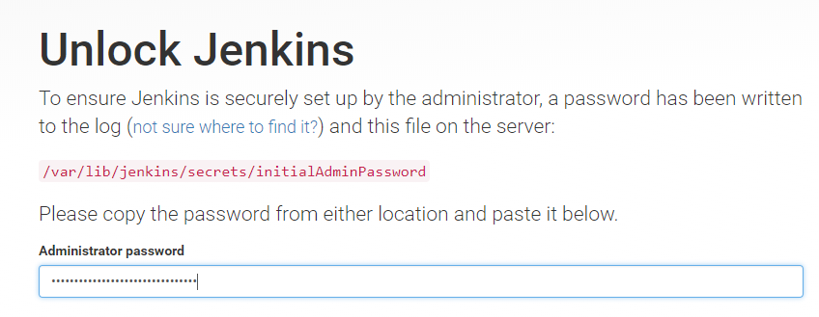

Click Install suggested pluggins

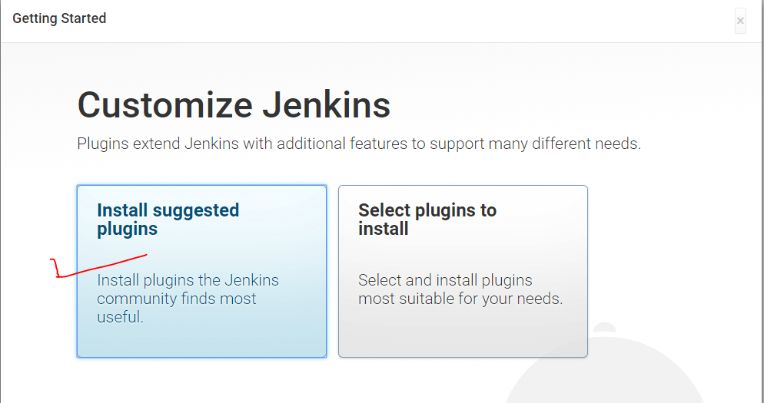

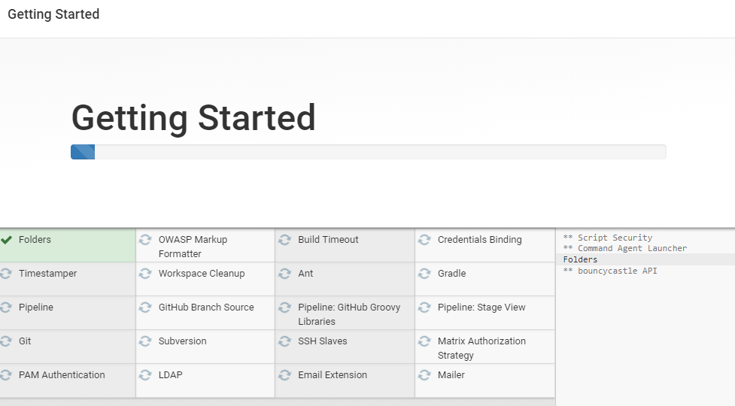

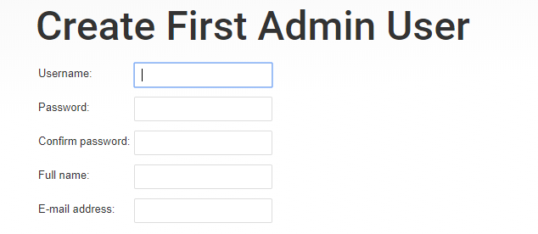

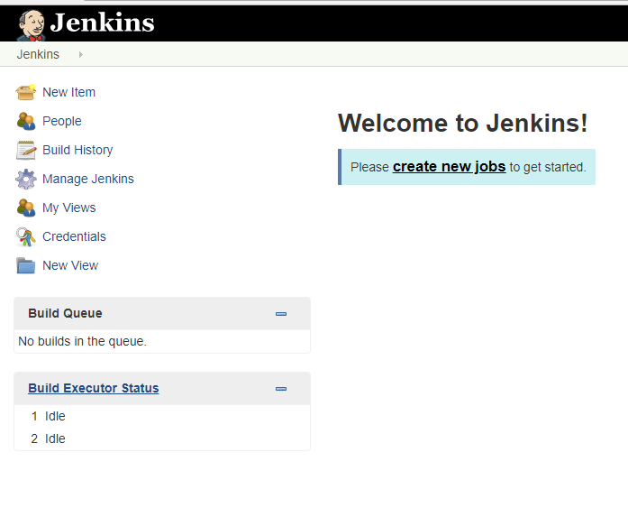

Go to manage jenkins-🡪configure Global Security

Change the options..see below pic

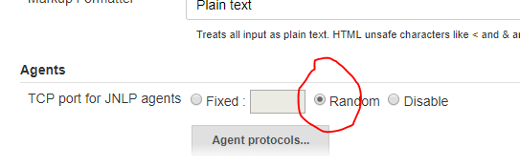

Now go to manage Jenkins 🡪manage node



Now create new node

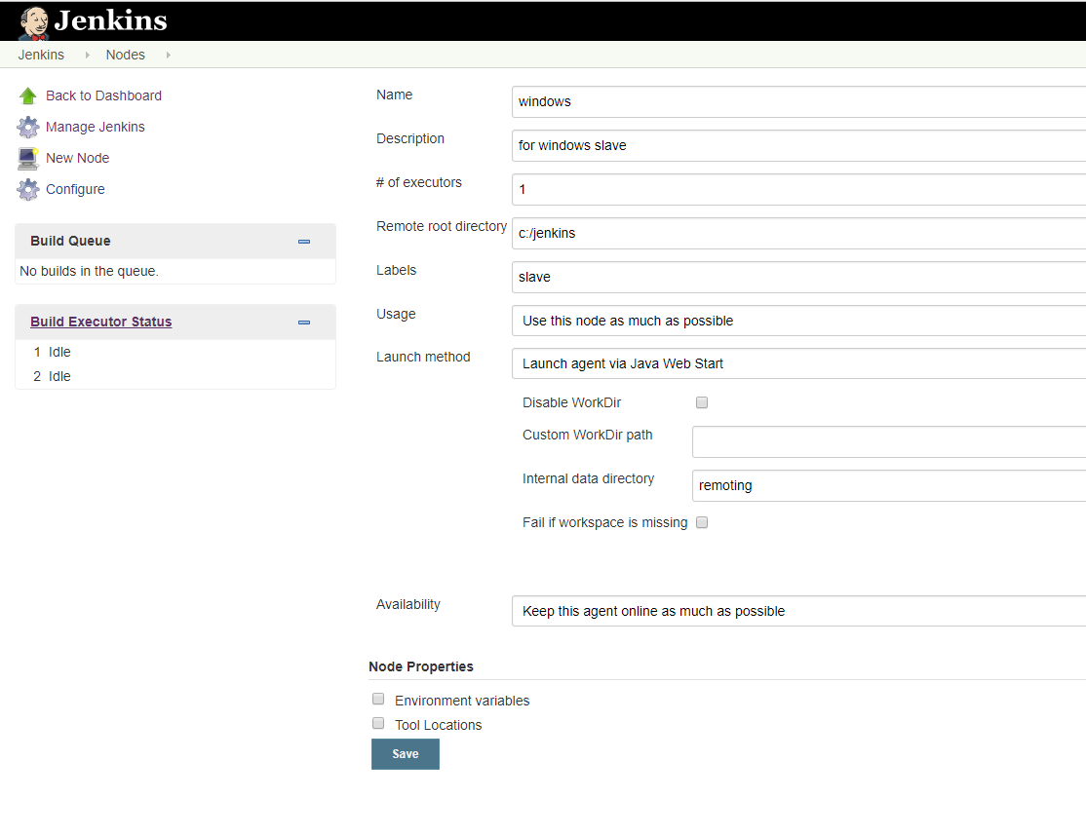

Here not connected

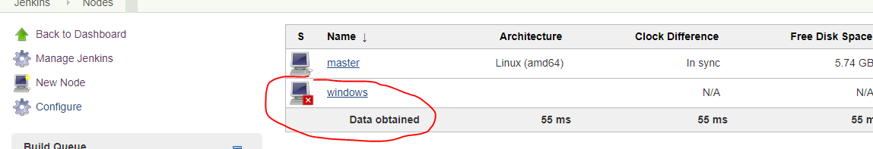

Now click” Windows” then it open like below pic

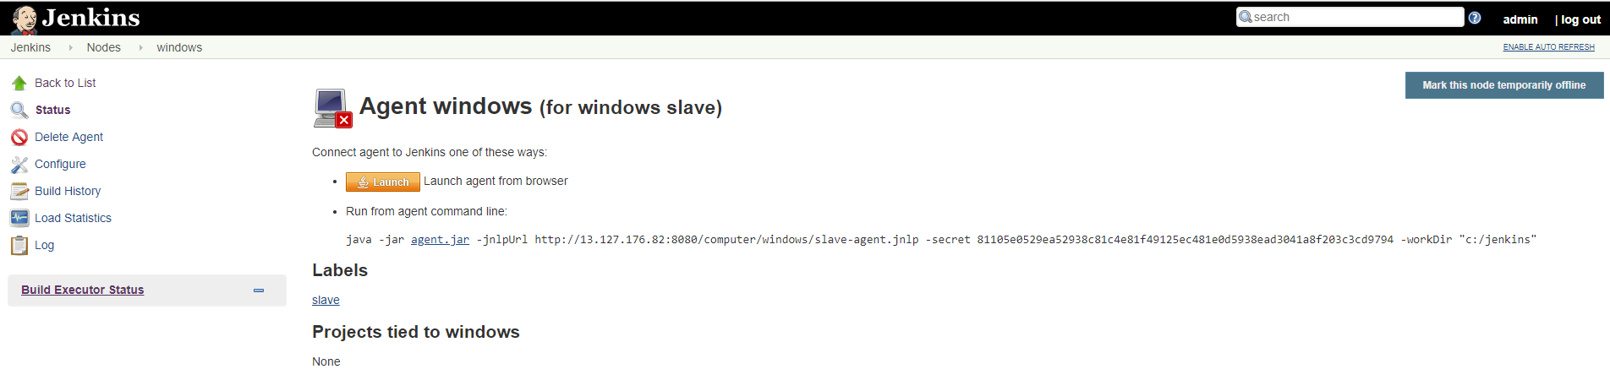

Now click Launch…Download slave.jar…then open it

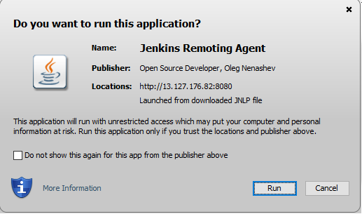

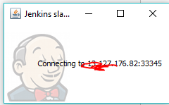

Copy that 33345 number

Open custum tcp

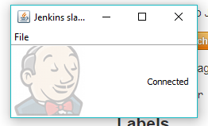

Now create one new job

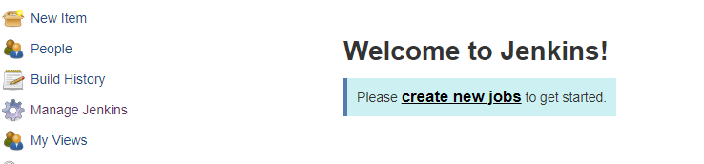

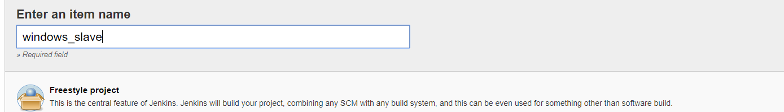

Take free style project

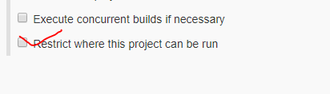

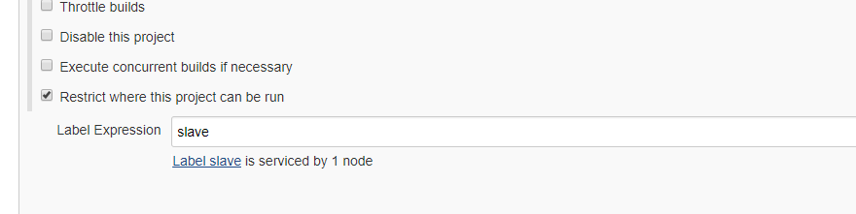

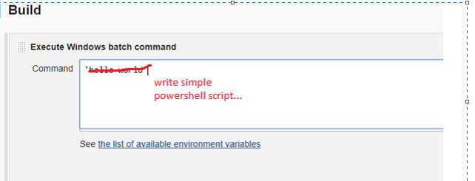

Save & apply

Build Now

See “console out put”